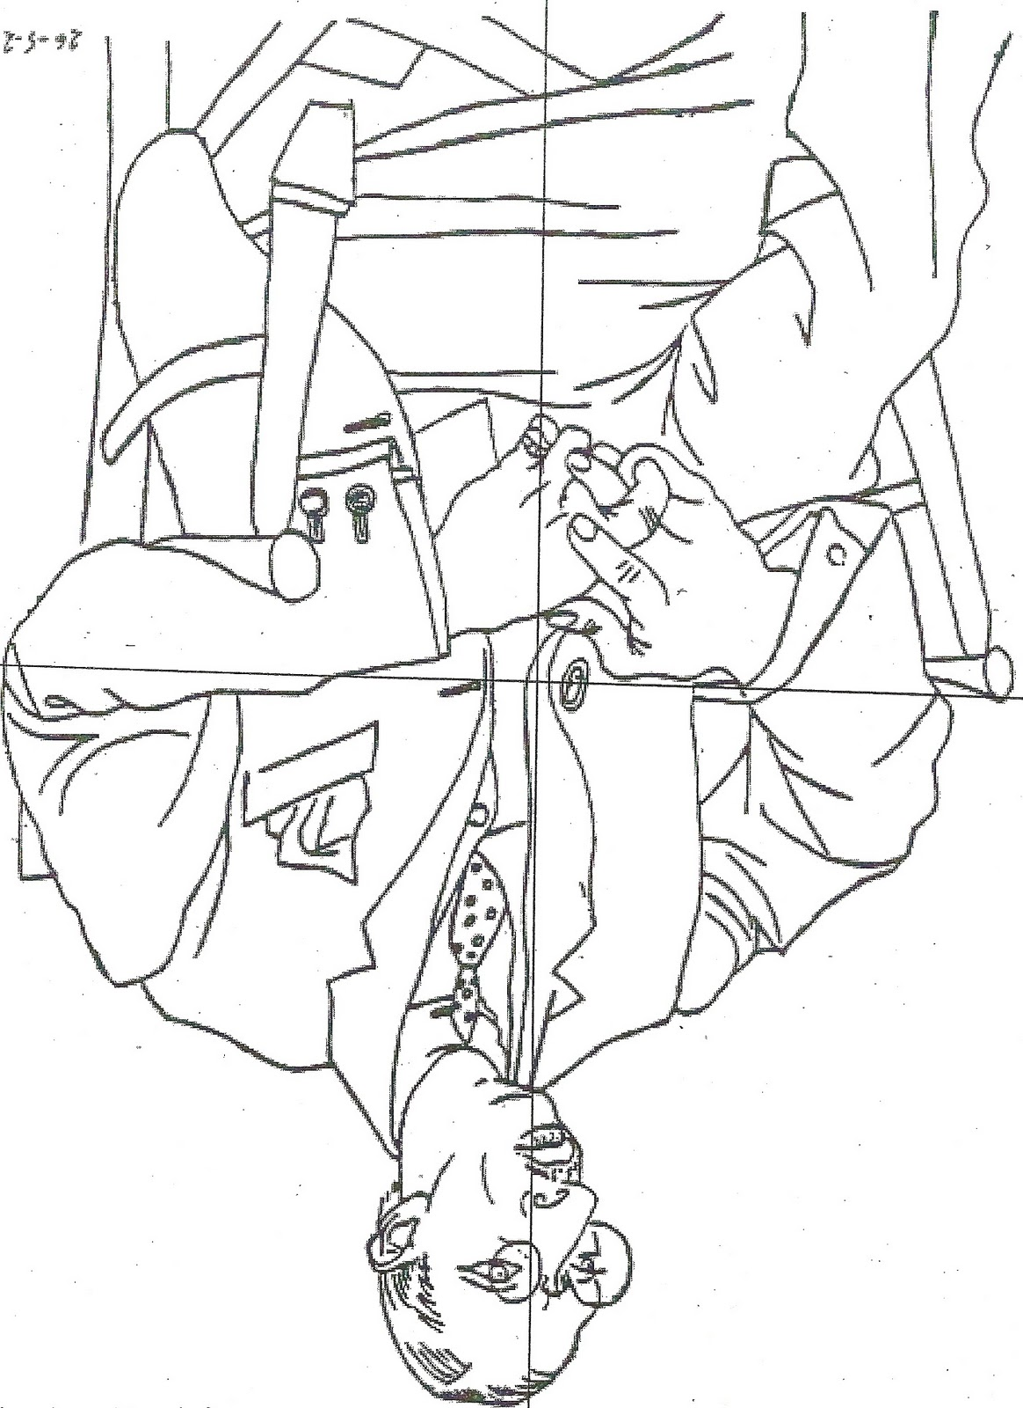

Pablo Picasso (1881-1973), Portrait of Igor Stravinsky. Paris, 1920.

